2303A523082
RUPALI
B-43 TASK-1 AND TASK-2
PROMPT 1: Zero-Shot Prompting (Palindrome Number Program)
PROMPT 2: One-Shot Prompting (Factorial Calculation)
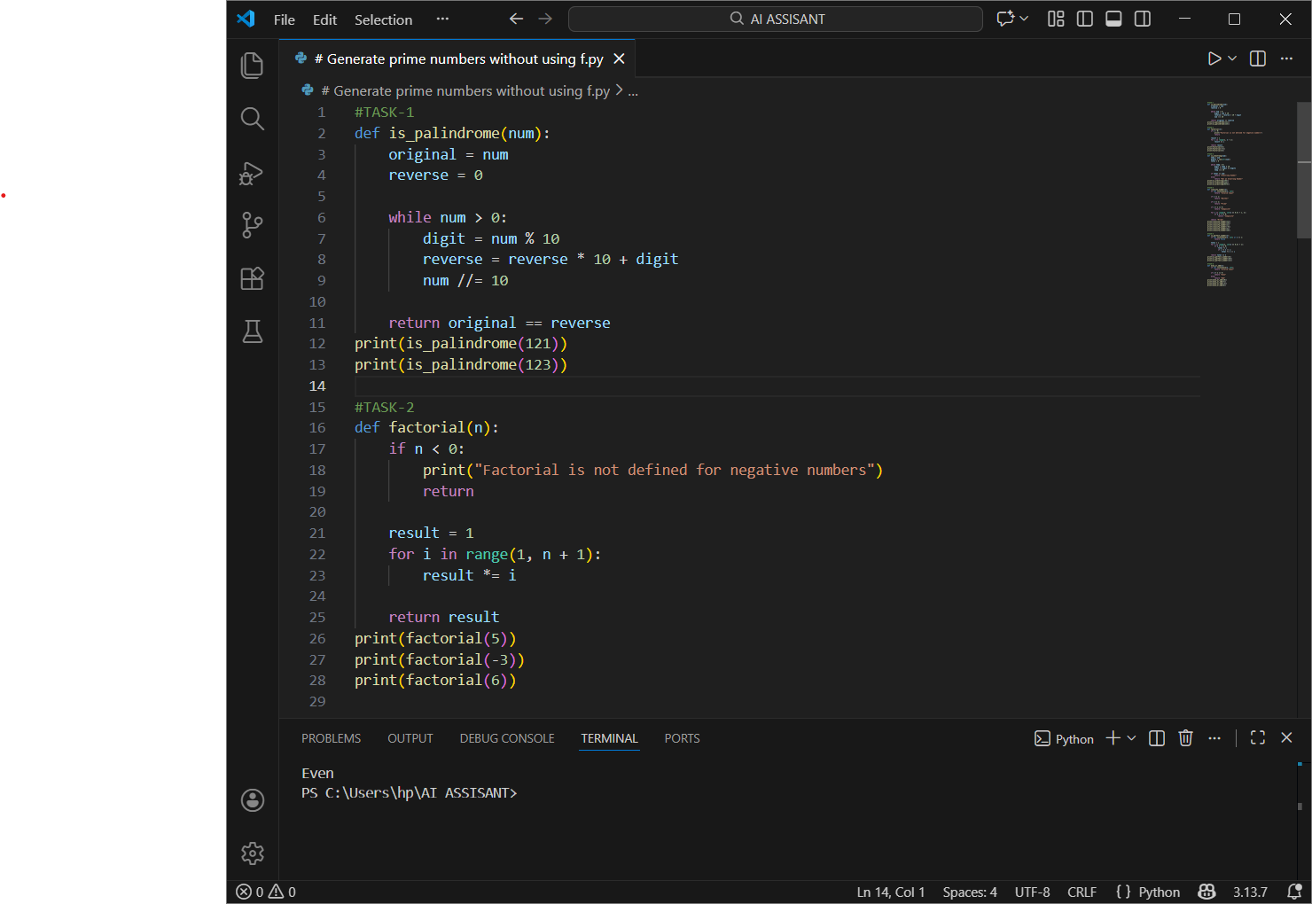

OUTPUT:
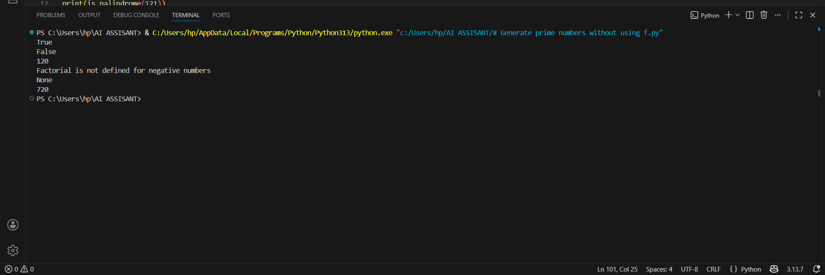

OBERVATIONS -1:
- The zero-shot prompt successfully generated working logic for positive integers.
- The solution correctly identifies most palindromes.
- Edge cases like negative numbers and invalid inputs require additional handling, which was not included due to the zero-shot constraint.

OBERVATIONS -2:
Works for single-digit, multi-digit, zero, and negative numbers
Uses pure arithmetic (no string conversion)
Suitable for zero-shot prompting evaluation.
TASK 3 AND 4
PROMPT 3: Few-Shot Prompting (Armstrong Number Check)
PROMPT 4: Context-Managed Prompting (Optimized Number
Classification)

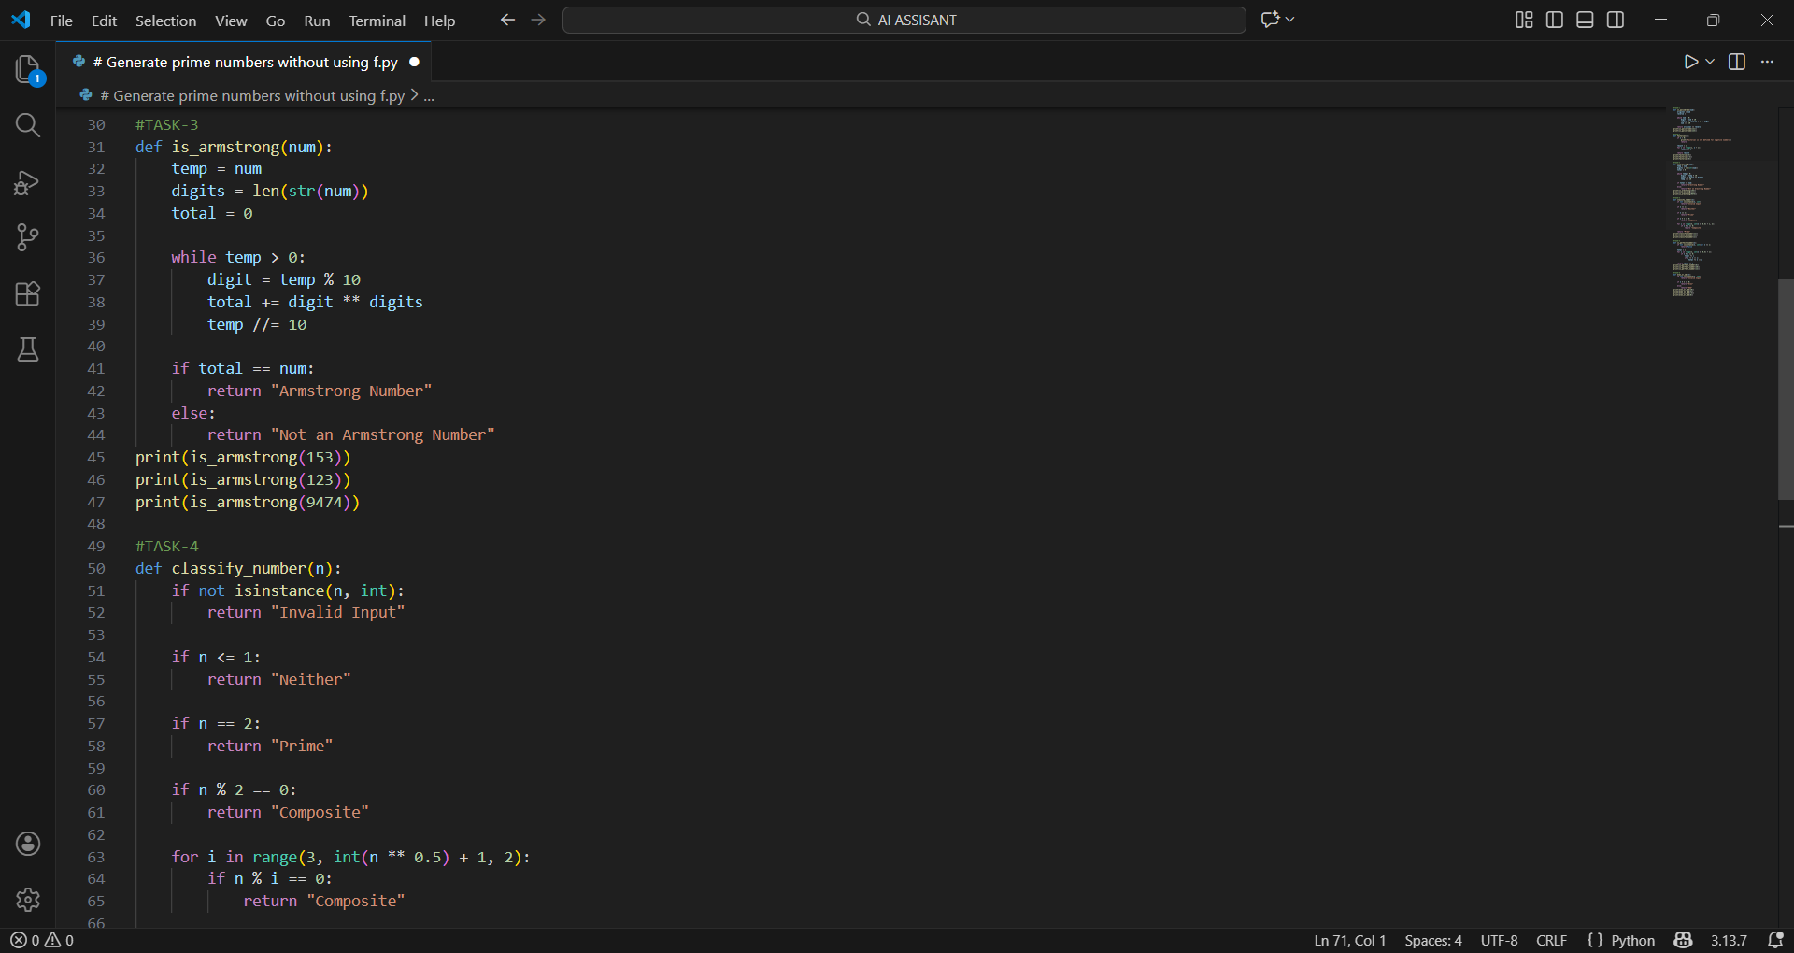
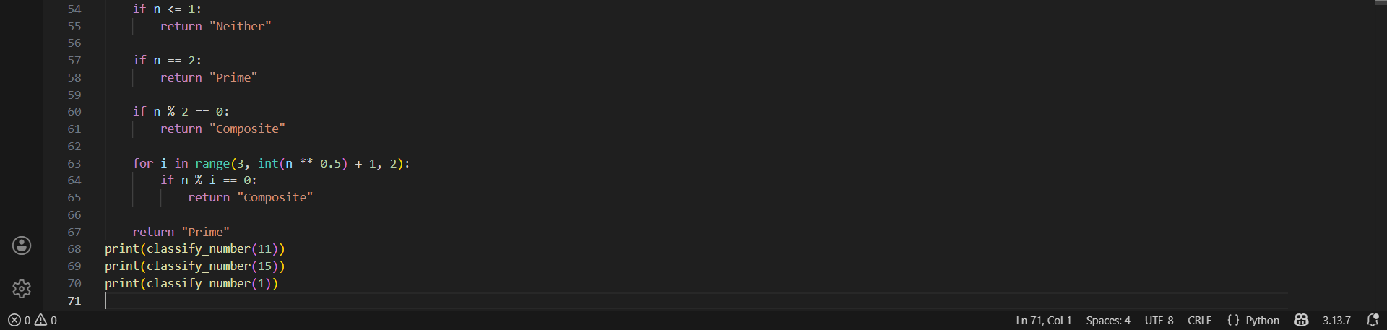

OUTPUT:
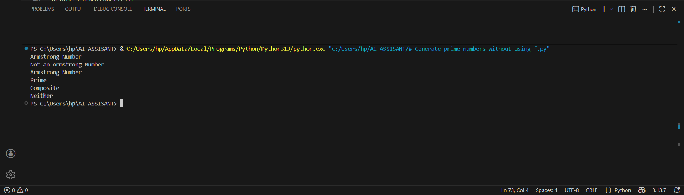

OBSERVATIONS 3:
1. High accuracy
- The AI correctly identifies Armstrong numbers.
2. Clear logic
- Uses digit count and power calculation as guided by examples.
3. Improved understanding
- Multiple examples help the AI infer the correct pattern.
OBSERVATION 4:
- √n optimization
  - Divisibility checked only up to square root of the number.
- Skipping even numbers
  - After checking 2, only odd divisors are tested.
- Early exits
  - Improves performance by stopping as soon as a divisor is found.

TASK 5-6
PROMPT-5: Zero-Shot Prompting (Perfect Number Check)
PROMPT-6: Few-Shot Prompting (Even or Odd Classification with
Validation)

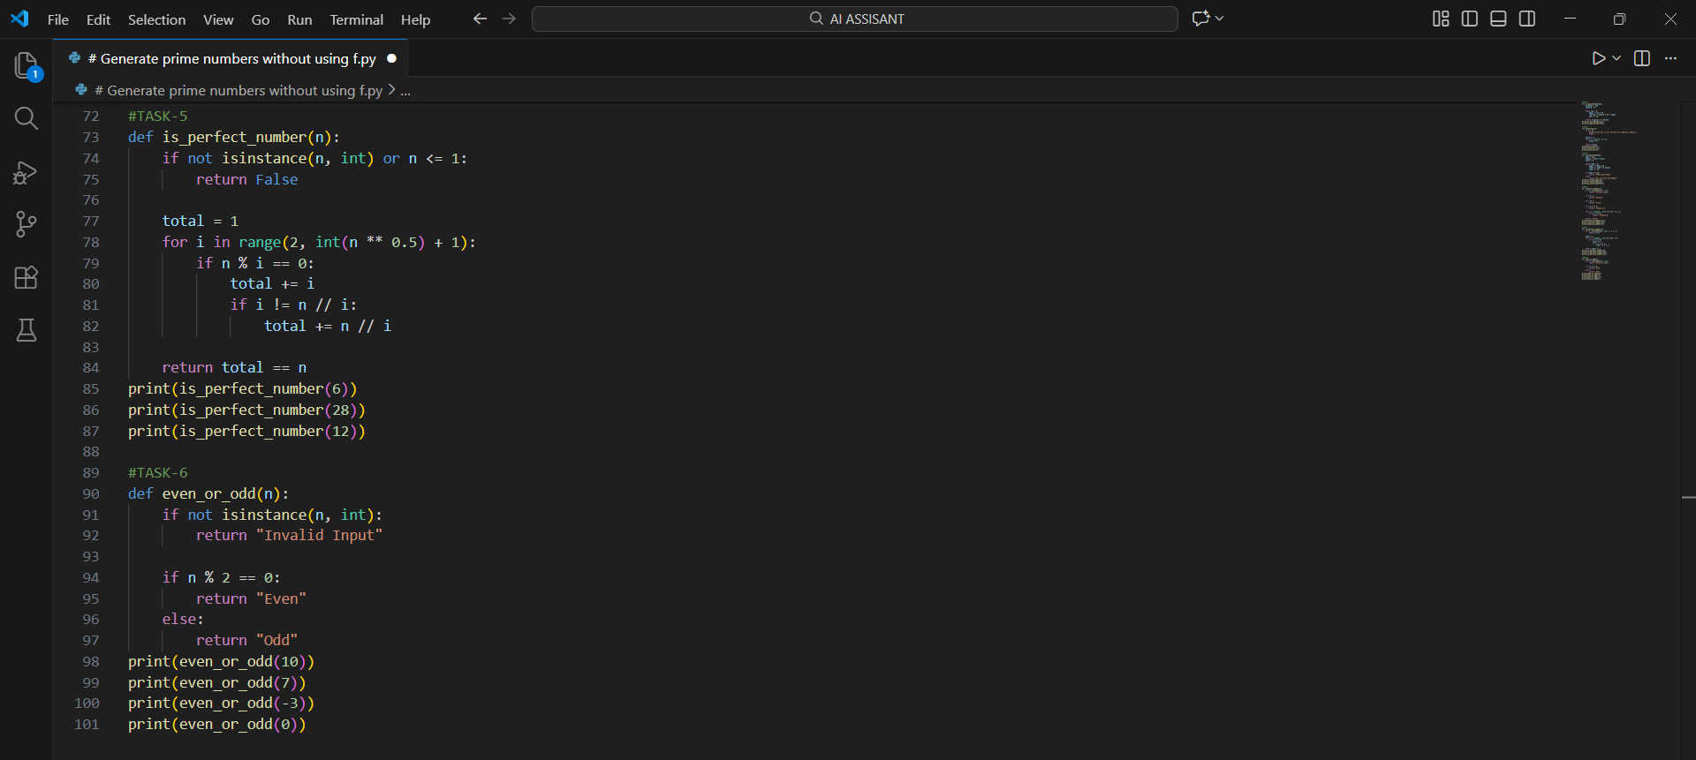

OUTPUT:
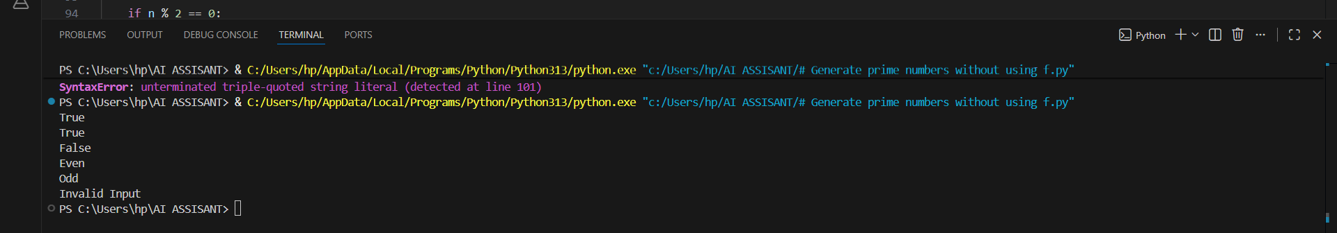

OBSERVATION 5:
- Zero-shot prompting produces correct but basic logic.
- The generated code works for small inputs but lacks efficiency and validation.
- Optimized logic and constraints significantly improve performance and robustness.
OBSERVATION-6:
Improved Input Handling
- Examples clarify that 0 is even, reducing ambiguity.
- The AI includes type checking to reject non-integer inputs.
🔹 Output Clarity
- Consistent string outputs: "Even", "Odd", "Invalid Input".
- Avoids ambiguous boolean values.
🔹 Handling Edge Cases
- Correctly handles negative integers

